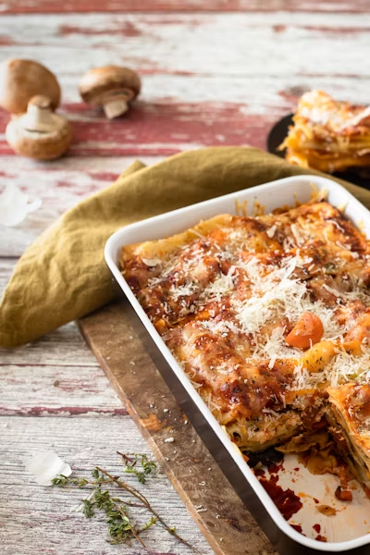

**Main Meal Deal**

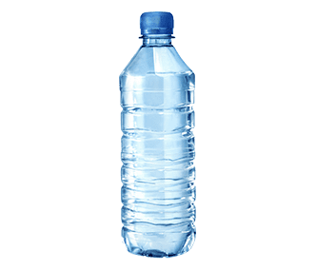**Your Choice of Main Meal With**

**Any Home Bake**

**or Still Water**

**£2.90**

**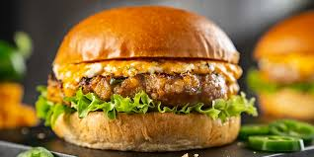*Grab ‘n’ Go Meal Deal***

**Hot Grab ‘n’ Go Choice of the Day**

**With Any**

**Home Bake**

**or**

**Still Water**

**£2.90**