[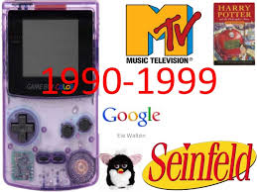](https://www.google.co.uk/imgres?imgurl=https://image.slidesharecdn.com/1990s-140517144152-phpapp01/95/1990s-1-638.jpg?cb%3D1400337770&imgrefurl=https://www.slideshare.net/ENSFCEnglish/1990s-34806050&docid=Gnlyiqmot0l3EM&tbnid=NnRJZv0GDqGNtM:&vet=10ahUKEwih-YO4j_jZAhUKKcAKHRoVDPgQMwiAASgMMAw..i&w=638&h=479&safe=vss&bih=556&biw=1128&q=1990's%20images&ved=0ahUKEwih-YO4j_jZAhUKKcAKHRoVDPgQMwiAASgMMAw&iact=mrc&uact=8)